Vermont Psychological Services
Leitenberg Center for Evidence-Based Practice
___________________________________________________________________
Department of Psychological Science, University of Vermont
2 Colchester Avenue, Burlington, Vermont 05405-1764
Phone: (802) 656-2661 Fax: (802) 656-3485
Phone: (802) 656-2661 Fax: (802) 656-3485

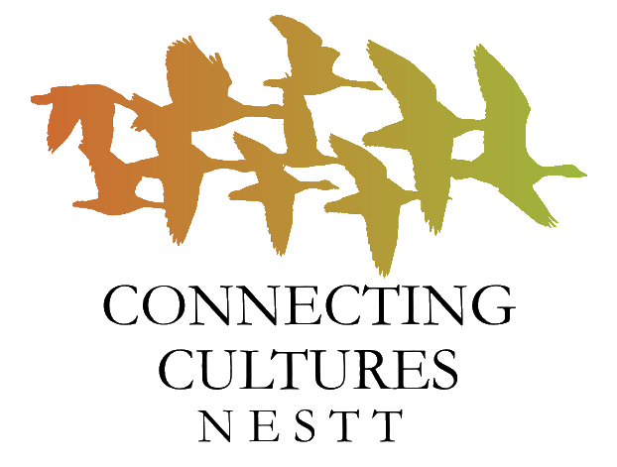

CONNECTING CULTURES REFERRAL FORM
Please complete this form and send via email susan.martel@vps.hush.com OR fax to (802) 656-3485 OR call (802)-656-2661 and leave a voicemail with all information listed on this form to make a referral to Connecting Cultures.

Client Name:  Client’s Date of Birth:  If Client is a student, please provide:  Name of School: | Date:  Gender:  Student’s Grade:
Parent/Guardian Name(s):  Phone Number(s) for:  Client:  and/or Parent/Guardian: |  | Permission to leave a voicemail?  Yes No  Permission to say “Connecting Cultures?”  Yes No
Country of Origin:  Language(s): |  | Interpreter Required for:  Parent/Guardian Client
Health Insurance Info (If available):  Type: |  | Number:
Referral Source:  Name:  Agency: |  |  | Phone:  Email:
General Nature and Severity of Problem:

Please indicate referral services (check category and any specific factors that apply):
*Please see the backside of this sheet for referrals we cannot accept and other appropriate sources
☐Psychological Services  ☐Suicide Risk ☐Torture/trauma survivor  ☐Homicide Risk ☐Substance use  ☐Dep or Anx ☐Chronic Pain / Disability | ☐Short-term & Focused Case Management  ☐Non-emergent housing ☐Transportation  ☐Benefits (e.g., food stamps) ☐Post-Migration  ☐Chronic Health Management adjustment
☐ Legal Services (check any that apply):  ☐Asylum Process  ☐Citizenship or Immigration  ☐Forensic Evaluation | ☐ Physical Therapy  ☐ Evaluate and treat  ☐ Pain control  ☐ Strengthening/conditioning  ☐ Functional training

Please note that Connecting Cultures is not appropriate for the following referral needs:
- Individuals in crisis or reporting current suicidal or homicidal intent
Instead: Please contact First Call at 802-488-7777 or call 911

- Homelessness or emergency shelter support
Instead: Please contact COTS at 802-864-7402, or CVOEO at 802-862-2771

- Immediate domestic violence support
Instead: Please call 911 or contact STEPS at 802-658-1996

